**Crypts and Cryptograms**

**Team Members:**

Schafer Cunningham, Liam Ellinger, Trisha Nag, Krishna Patel, Sydney Pearson

**Description:**

The user plays as a character in a first-person perspective. This character has woken up in an unknown area of a house with no recollection of how they arrived there or how to escape. They must travel throughout the house, unlocking doors by solving puzzles, to reach the exit.

The house layout consists of a grid of rooms, one of which the user starts in. Each room contains different objects. Some objects allow for interactions while others do not. When interactable objects are clicked on, a close up of the object will be seen. The close up of the object will allow the user to see what the object is. These interactable objects will be able to aid the user in finishing the game. When non-interactable objects are clicked on, a text box will appear. In this text box, a simple message will state that this is simply an object that is not helpful to the user.

Each room will also contain a door. These doors may or may not be locked. If they are locked, the way to unlock the door will be some sort of puzzle. Hints to solve each puzzle, in the form of interactable objects, are scattered around the room the door is in. Once the puzzle is solved, the door will unlock and lead the user to another room.

**Potential Users:**

People with Android devices who are interested in puzzle-based games.

**Use Cases of Functionality:**

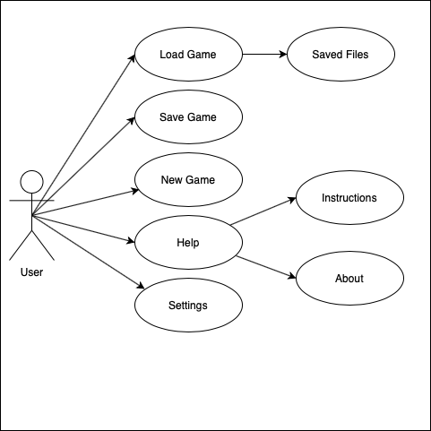

*Figure 1: Use Case Diagram*

***Load Game:***

Many video games allow the functionality to load a game. This means that, while playing, the user is able to save the game and start from that same save point at a later date. That can either be within the same game in the case that the user had done some task incorrectly or can be after opening the game to continue the game from that point.

***Saved Files:***

This goes hand-in-hand with the Load Game use case. The saved files are a collection of save points within different plays of the game. This allows the user to look through the different data and choose where they would like to start. If there is no saved data when the user navigates to this page, a blank page with the words “No Files” will be displayed. The user can also delete save data if they do not wish to have it anymore.

***Save Game:***

There will be two options for saves: autosave and manual saves. The autosave will occur after a set time. This ensures that the user’s game data is saved so that they will be able to continue the game where they left off, should they so choose to. The manual option can be accessed through an in-game menu. This allows the user to decide when they would like to save their game data.

***New Game:***

To start off the game, the user will select this option from the main menu. This will start the game from the very beginning, putting the user in the first room of the house with every door locked. This option can also be accessed from the in-game menu. If the user feels like they messed up or they decided they just want to start over, they can select this option. It will start a brand new game with the user starting in the first room with all the doors locked.

***View Map:***

As the user moves around the house, a map makes itself available. It shows the current rooms that have been opened by the users and black boxes in the other rooms. This shows the user what they have accomplished and what other rooms they have left to explore.

***Help:***

This can be accessed from both the main menu or the in-game menu. This tab will open up two options: instructions and about.

***Instructions:***

Users can find this under the Help tab. This page will help the user play the game. It will explain the basic functions of the game, how to use objects, how to unlock doors, and other tips and tricks to solve the game.

***About:***

This is a basic description of the game. It will explain the basic storyline of how the game works (i.e. the user is a character lost in a house etc.). This will also contain the credits to the game which includes the names of the team members and what each of them contributed.

***Settings:***

The settings tab will contain user settings. This includes volume, brightness

**Contributions:**

**Schafer:**

* Helped set up the team with Android Studio and emulators
* Created the user interface for the app’s home page
* Assisted with the development of the Use Case Diagram
* Assisted in creating the base master branch file to GitHub for everyone to link their Android studio to

**Liam:**

* Created .gitignore file
* Created interactable object files
* Linked objects to button actions
* Drew game window
* Removed local files from repository

**Trisha:**

* Helped team set up local branches for individual development and organize files properly in both local and remote repositories
* Added a file for git bash commands to help us overcome Android Studio’s UI
* Managed pull requests
* Assisted with .gitignore file for each branch

**Krishna:**

* Created and added README
* Assisted Trisha with helping the team get accustomed with Git
* Created storyboard to show how the game will flow from one screen to the next
* Assisted in fixing the GitHub repository when a problem regarding the structure arose

**Sydney:**

* Designed what will be the main message box in the game
* Enabled the main message box to display new text in response to touch input
* Pieced together the activities of displaying the main message box and displaying the dungeon screen to the two start menu buttons New Game and Load, respectively. This took forever because initially the app just crashes when loading new activities
* Worked on (unsuccessfully) using the Timer and TimerTask to make the textbox arrow blink independently. For now it becomes visible and invisible every other message until this is fixed.